AT EACH STATION we genuflect and say:

Deacon: We adore you O Christ and we bless you;

ALL: Because by your holy cross you have redeemed the world.
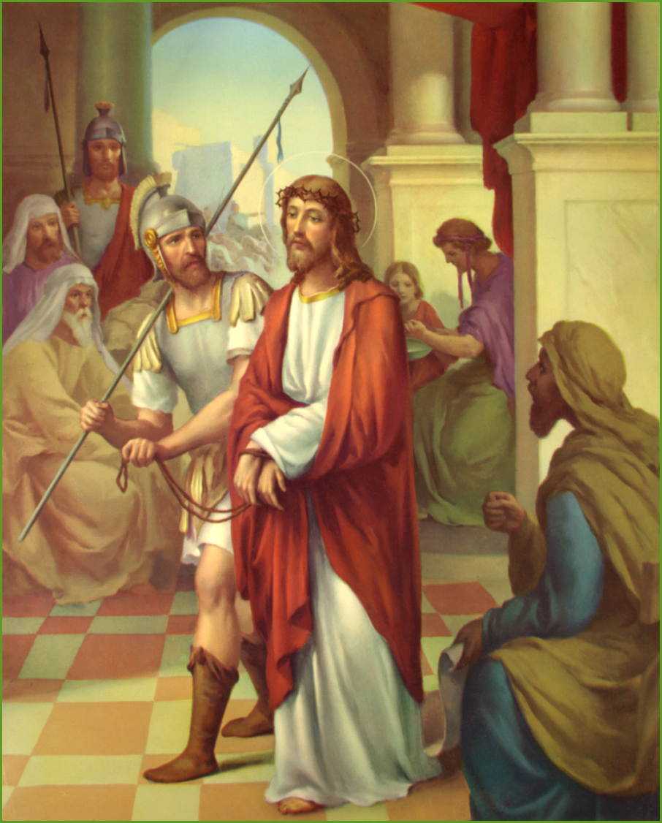
1. Jesus is condemned to death. Jesus was accused of many crimes he didn’t commit. He didn’t defend himself. He knew he needed to die for our sins.
Prayer: Jesus, I often cover up my wrong-doing. Help me be honest. Help me not to accuse others of doing wrong.
Holy Mary pray for me; teach me to love Jesus.

AT THE END OF EACH STATION WE SING TWICE:
“Jesus, remember me, when you come into yor kingdom.”

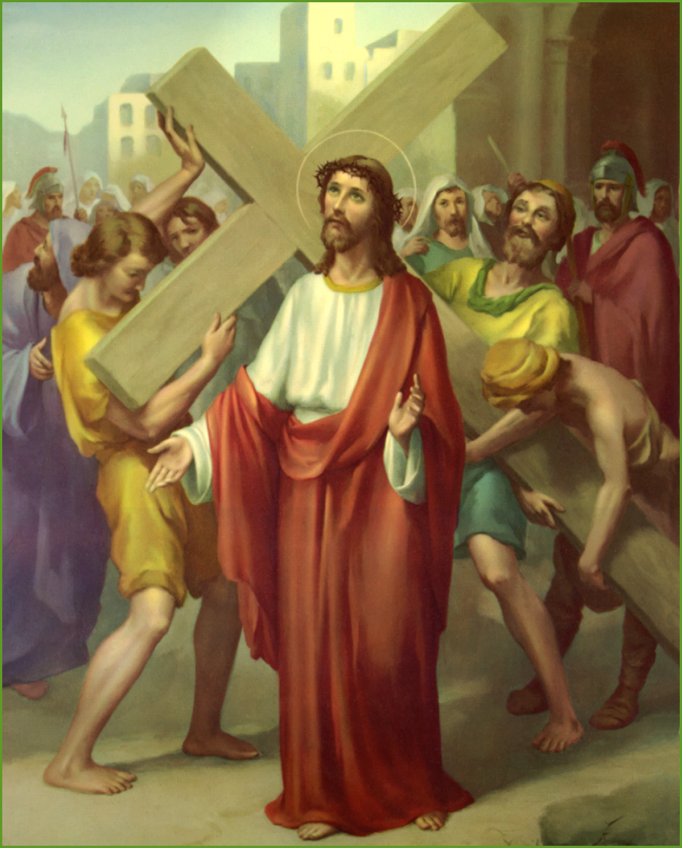
2. Jesus accepts the cross. The cross was big and heavy. It was hard for Jesus to carry it. Jesus carried the heavy cross without complaining once.
Prayer: Sometimes schoolwork or jobs at home are hard for me and I complain. Jesus, please help me not to complain. I want to keep trying, even when I find something hard to do.
Holy Mary pray for me; teach me to love Jesus.

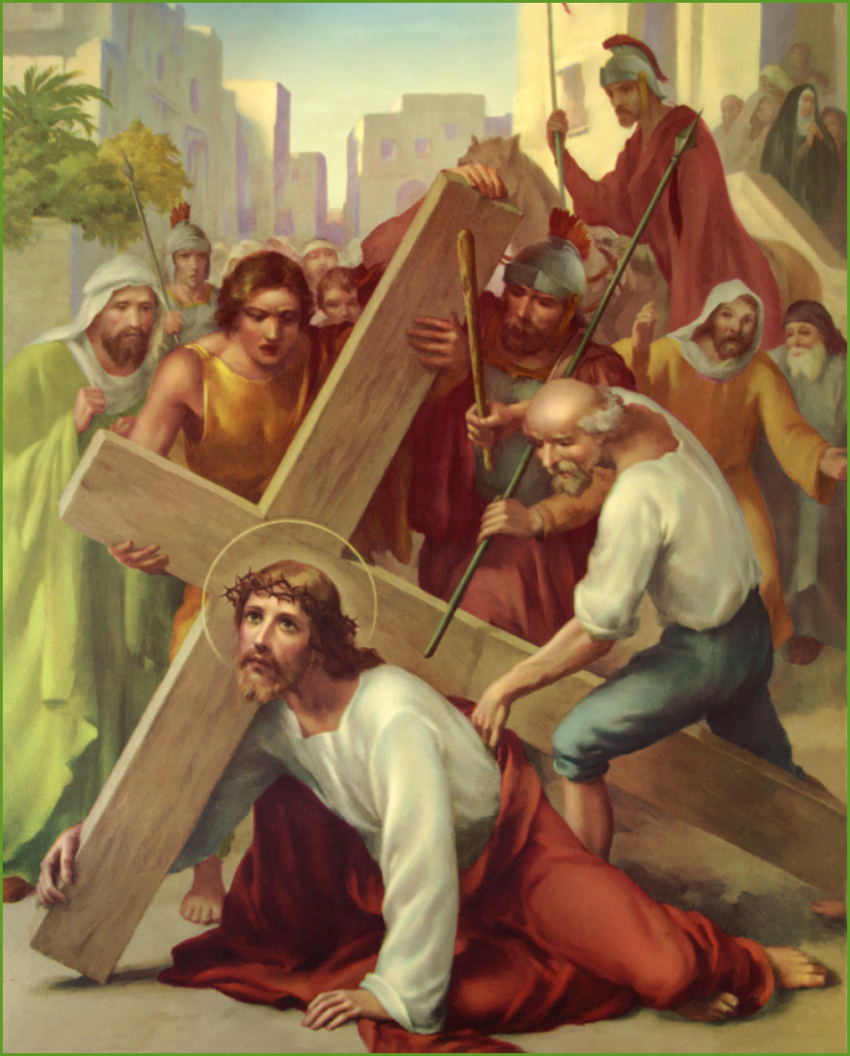
3. Jesus falls the first time. Jesuswas already badly wounded when he fell the first time. It must have hurt very much. Jesus got up and kept on going.
Prayer: When we don’t succeed in school or when we lose a sports game, it can make us feel defeated. Jesus was hurt but never defeated. Jesus, I want your attitude of hope and victory even if I am not succeeding.
Holy Mary pray for me; teach me to love Jesus.

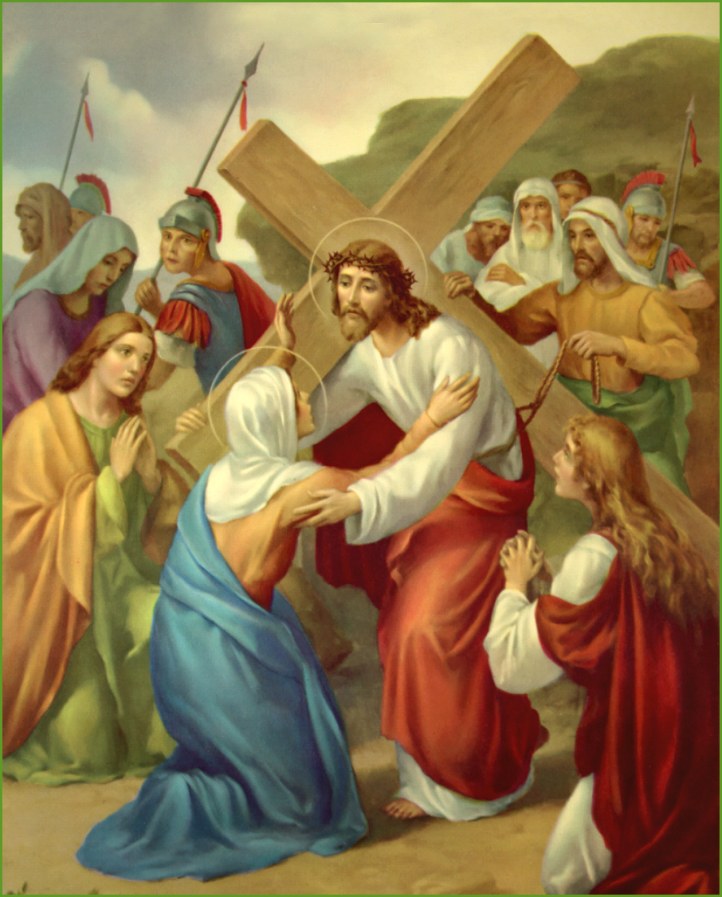
4. Jesus meets his mother. Jesus knew that his mother was sad to see him suffering so much. But he was so happy she came to him. Mary and Jesus loved each other very much.
Prayer: Our parents love us very much, and sometimes we don’t let them hug us and care for us because we are mad or sad. Jesus, I thank you for my parents and their love for me.
Holy Mary pray for me; teach me to love Jesus.

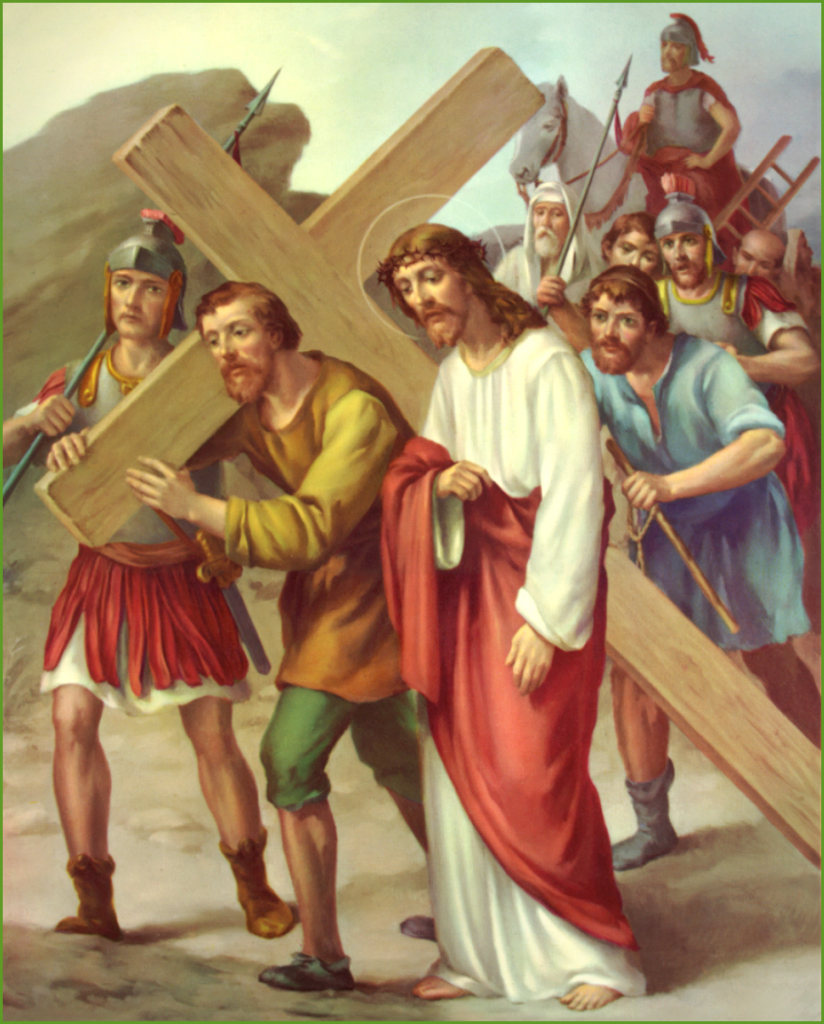
5. Simon of Cyrene helps Jesus. Simon had only come to see what was going on. Then he was ordered by the soldiers to carry the cross, because Jesus was having such a hard time.
Prayer: Sometimes I don’t want to help my friends or brothers and sisters or parents when I am told to. Jesus, help me know that when I do help others, it is like helping you.
Holy Mary pray for me; teach me to love Jesus.

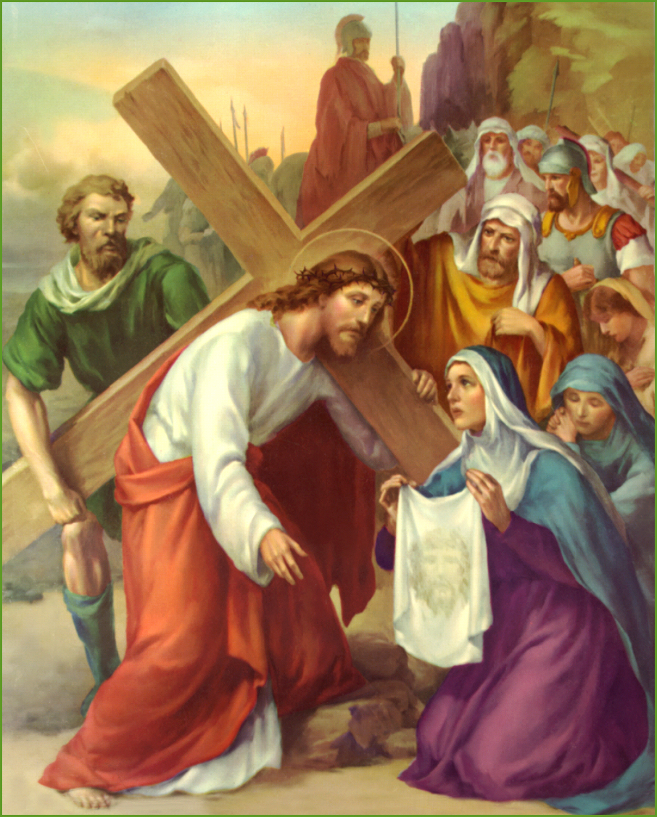
6. Veronica wipes Jesus’ face. Veronica loved Jesus very much. When she stepped out to wipe his face, she risked big trouble from the soldiers. Her love and kindness overcame her fear.
Prayer: Jesus, I want to love you like Veronica. Help me to be brave and love others who are unpopular.
Holy Mary pray for me; teach me to love Jesus.

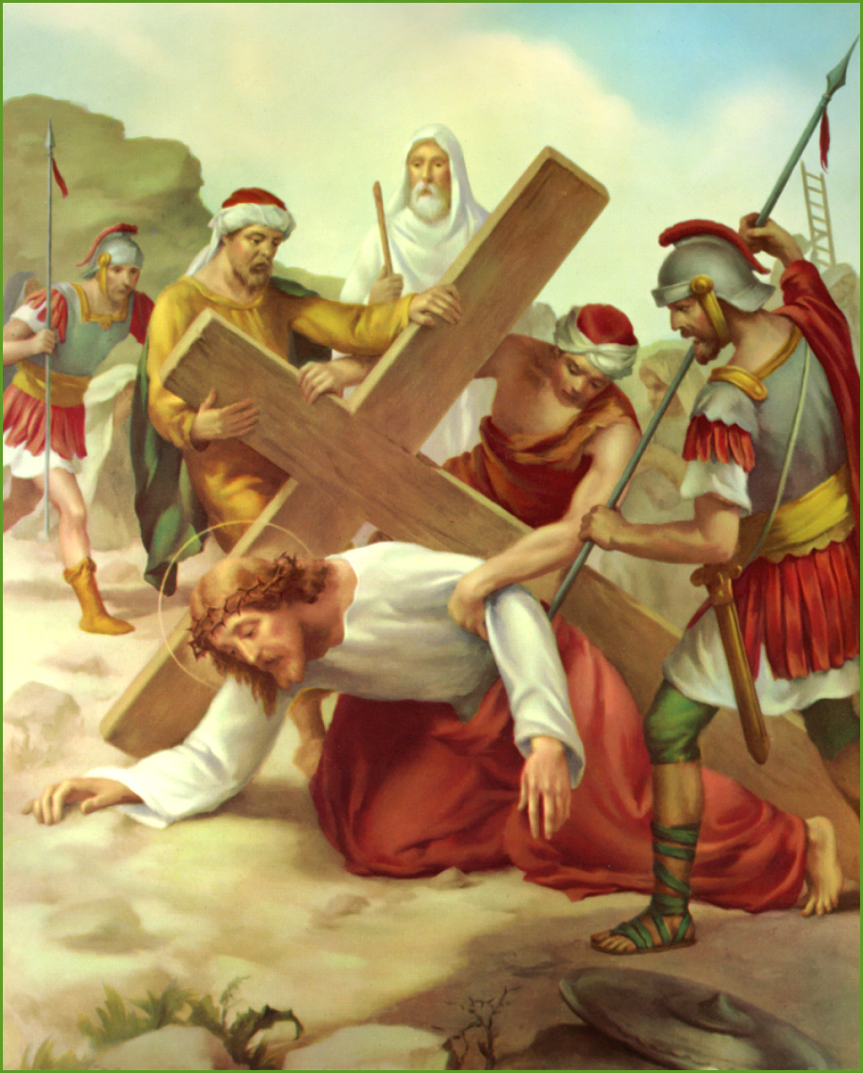
7. Jesus falls a second time. Jesus fell again because he was so weak and tired from all his wounds. He still didn’t give up. He got back up and continued on.
Prayer: When something makes me feel weak, something that is hard for me to do, Jesus, I ask to help me.
Holy Mary pray for me; teach me to love Jesus.

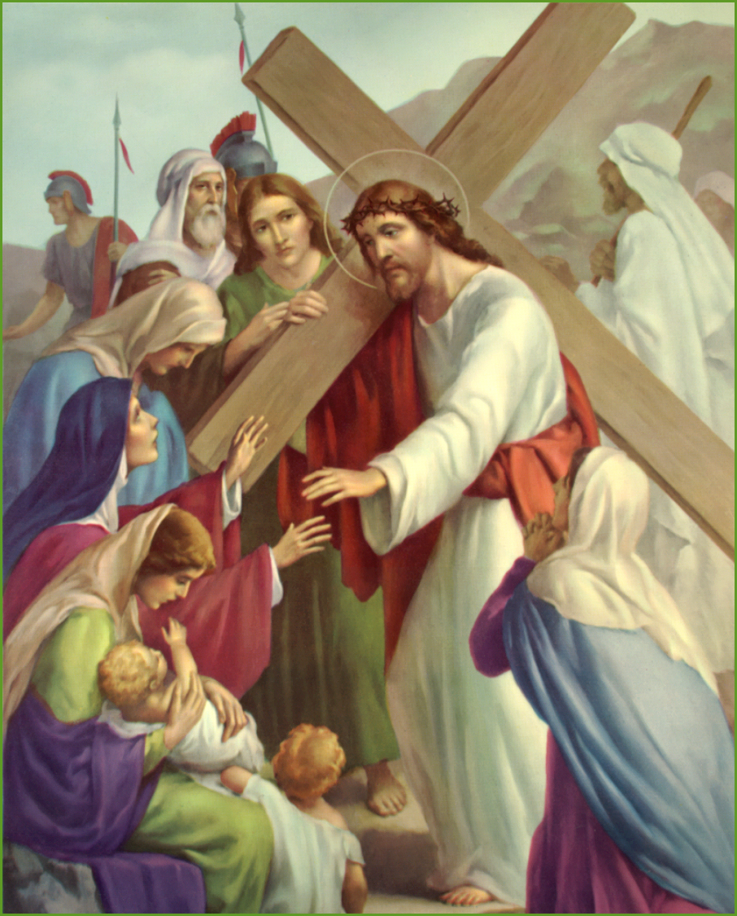
8. Jesus meets the women of Jerusalem. A lot of people were against Jesus, but a lot of people followed him. They were his faithful friends.

Prayer: Help me to be a faithful friend. When my friends are going through a hard time or are being made fun of, I want to help them and be a true friend.
Holy Mary pray for me; teach me to love Jesus.

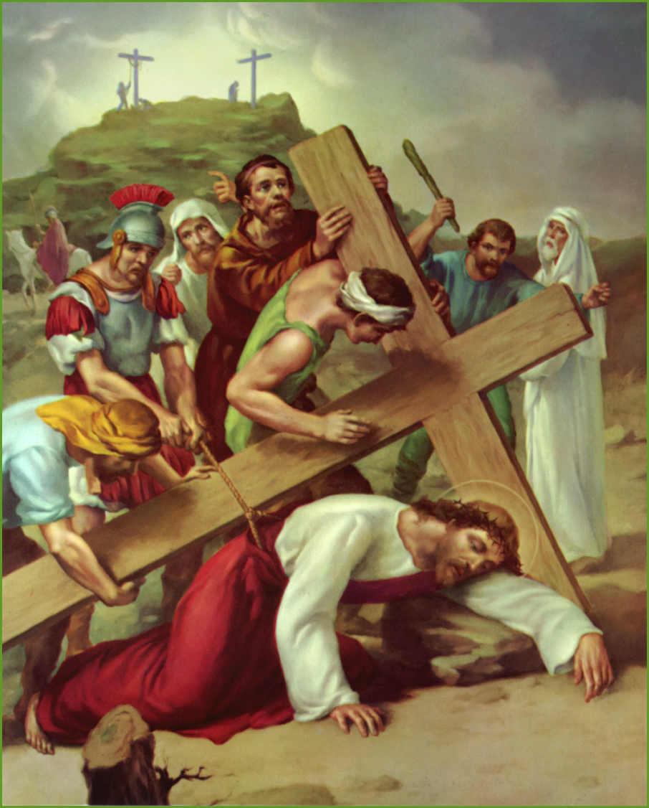
9.. Jesus falls a third time. It’s unbelievable that Jesus fell again and the soldiers didn’t help him. They only yelled louder for him to get up and continue on. Jesus didn’t get mad at them; he forgave them.
Prayer: Sometimes people say or do hurtful things to us or don’t help us when we need them. Jesus, help me to forgive everyone like you did. Help me not to get angry or hold a grudge against someone who has hurt me.
Holy Mary pray for me; teach me to love Jesus.

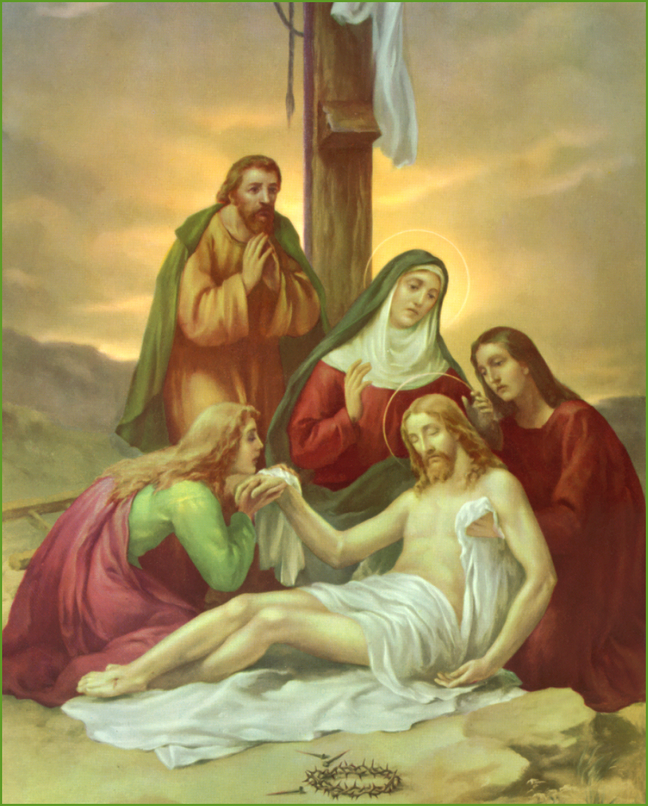
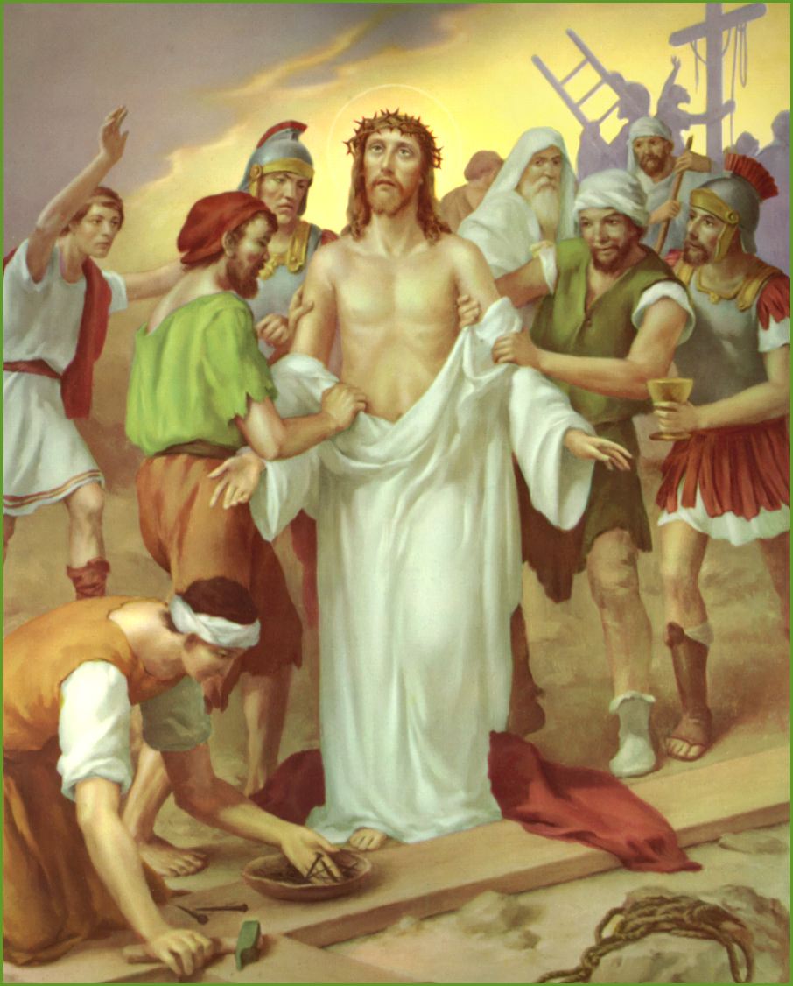
10. Jesus is stripped of his clothes. To be without clothes in front of everyone is a humiliating thing. Jesus wasn’t ashamed because he knew his Father in heaven loved him.
Prayer: Jesus, I want to know how much you and the Father love me, so I will never be embarrassed or ashamed.
Holy Mary pray for me; teach me to love Jesus.

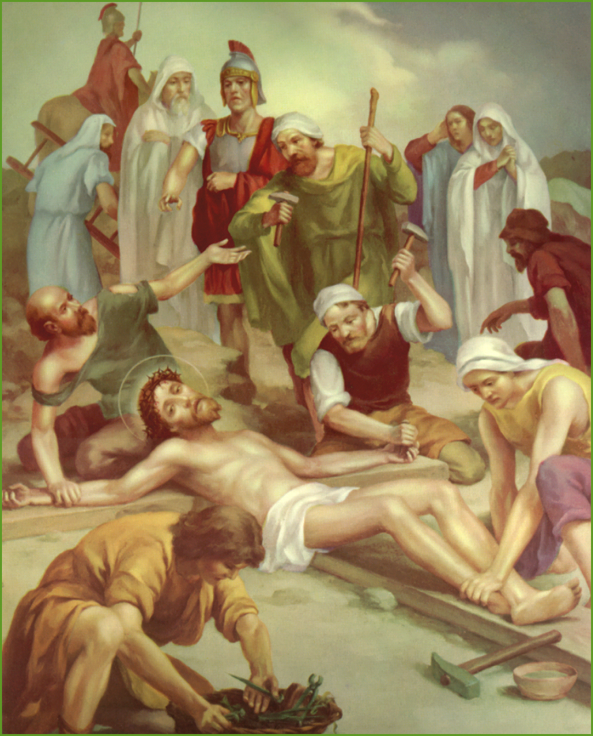
11. Jesus is crucified. The soldiers drove nails through Jesus’ hands and feet. They lifted up the cross and put it in place. Jesus was in a lot of pain.
Prayer: Many people suffer pain every day from being sick, hungry, poor, and because of war or natural disasters. Jesus, please comfort everyone who is in pain today.
Holy Mary pray for me; teach me to love Jesus.

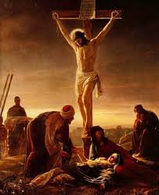
12. Jesus dies on the cross. When Jesus died, the sky got dark and the ground started to shake. This
made some people very scared. They saw that Jesus was innocent and that they had made a big mistake.
Prayer: Jesus, help me when I make mistakes. Help me to say I’m sorry. Thank you for always forgiving me. I love you, and I want to do the right thing.
Holy Mary pray for me; teach me to love Jesus.

13. Jesus’ body is taken down from the cross.
Joseph of Arimathea was one of Jesus’ friends, who took a risk and gave Jesus his own burial cave because Jesus didn’t have a place to be buried.
Prayer: Sometimes it is risky to step out and help people who are in need. Jesus, I want to help others. Give me love and courage.
Holy Mary pray for me; teach me to love Jesus.
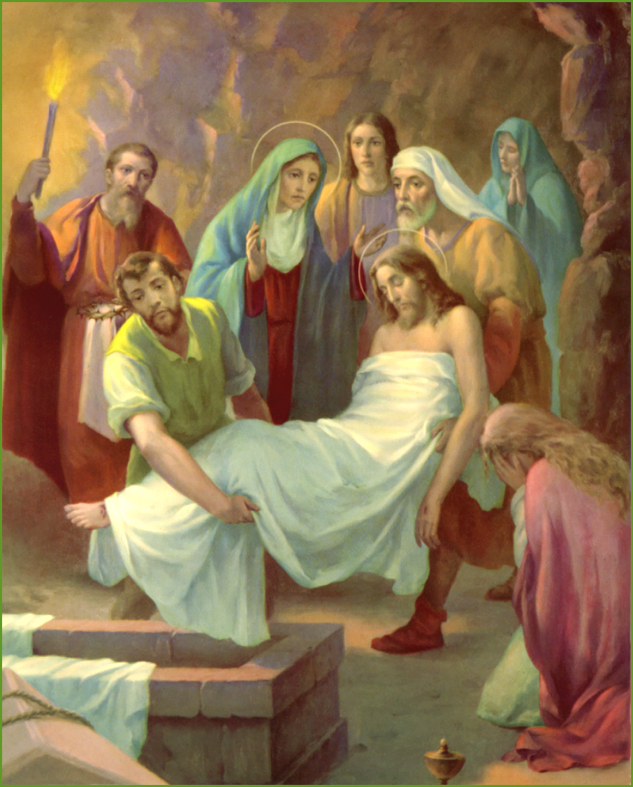
14. Jesus is laid in the tomb. Even when things look very difficult and sad, there is always hope that God can bring new life.
Prayer: Jesus, I believe that you died and rose from the dead so that I could have new life. Thank you!
Holy Mary pray for me; teach me to love Jesus.

IN FRONT OF THE ALTAR WE SAY TOGETHER:
“Christ has died; Christ is risen; Christ will come again!”

Young People’s

Stations of the Cross for Lent

at

St Mary’s

St Mary’s Brewood is part of the Archdiocese of Birmingham. Registered Charity no: 234216

