The Stations of the Cross

with Mary
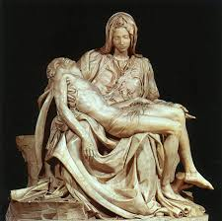

St Mary’s Brewood
part of the Archdiocese of Birmingham.
Registered Charity no: 234216

Opening Prayer:
God of power and mercy,
in love you sent your Son that we might be
cleansed of sin and live with you forever.
Bless us as we gather to reflect
on his suffering and death
that we may learn from his example
the way we should grow.
We ask this through that same Christ, our Lord.
Amen.

BEFORE EACH STATION:
We adore you, O Christ, and we bless you.
Because by your holy cross you have redeemed the world.

AFTER EACH STATION:
Lord Jesus, help us walk in your steps….(pause)
I love you Jesus, my love above all things.
I repent with my whole heart for having offended you. Never permit me to separate myself from you again. Grant that I may love you always,
and then do with me what you will.

(After each station, you may chose to sing the verses of
‘Stabat Mater’ or some other hymn/chant, e.g.
“Jesus remember me, when you come into your Kingdom.”)

THE FIRST STATION:
JESUS IS CONDEMNED TO DIE.

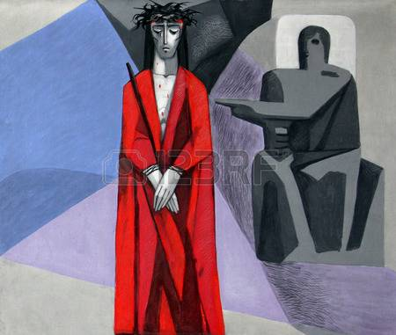
The mob kept shouting, ‘ “Crucify him.”
¹⁴ And Pilate said to them, “Why, what evil has he done?”
But they shouted all the more, “Crucify him.”
¹⁵ So Pilate, wishing to satisfy the crowd, released for them Barab′bas; and having scourged Jesus,
he delivered him to be crucified.’ ^{(Mk. 15: 13-15).}
REFLECTION.
My Son stood before Pilate as an innocent man. He grew up in obscurity in Nazareth. And, they always judged him there. Even when he began his public ministry, the religious leaders didn’t accept him. Finally, his own followers abandoned him.
While he was growing up, I told him many times how I had been graced to say “let it be done to me, according to your word.” I never could have imagined that this would be the sword that would ultimately pass through my heart: to watch my Son say Yes to God, so completely and fully, for the salvation of the world.
Let us ask for God’s grace to be with him and to accompany him on his journey to understand it more fully and be more fully grateful for its gift.
Lord Jesus, help us walk in your steps….(pause)…

THE SECOND STATION:
JESUS CARRIES HIS CROSS.
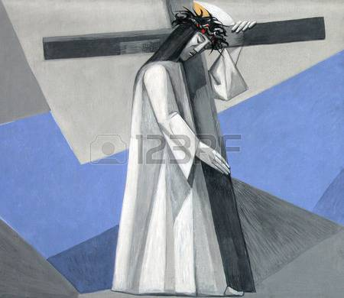
‘And when they had mocked him, they stripped him of the purple cloak, and put his own clothes on him. And they led him out to crucify him.’ ^{(Mark 15:20)}

My Son was forced to carry the cross on which he would be nailed, ridiculed and executed. We must pause here to remember what it represents. For this journey, he takes up the weight of all of our crosses, all of our senseless suffering, and the weight of all of the sin in the world – past, present and future. Each step he took cut deeply into his already battered shoulders. I couldn’t believe he could manage even a few steps.
We can look back now and remember that this is all for us. Each of us can say it was “for me.” As we imagine each step he takes, we can pause now to say “thank you,” in our own words, deep in our hearts.
Lord Jesus, help us walk in your steps….(pause)…

THE THIRD STATION:
JESUS FALLS THE FIRST TIME.
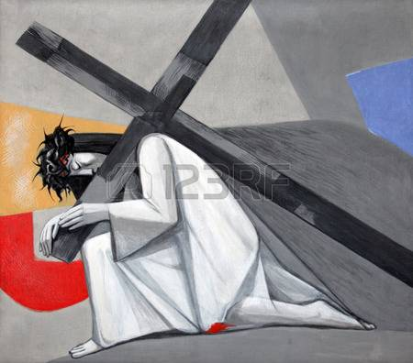
When the child Jesus was presented in the Temple, Simeon ‘took him up in his arms and blessed God and said, “Lord, now lettest thou thy servant depart in peace,
according to thy word; for mine eyes have seen thy salvation which thou hast prepared in the presence of all peoples, a light for revelation to the Gentiles, and for glory to thy people Israel.” ^{(Lk.2:29-32)}
Everything within me wanted to make them stop. when my Son fell under the weight of that cross. But, there was nothing I could do but watch him lay on the ground.
All the people of the earth who are overcome by unfair burdens will always know that, laying there on the ground, Jesus knew and would always understand their powerlessness; understands our fatigue and whatever unfairly defeats us.
I understand your sorrow at reflecting upon my Son’s way to Calvary. My Son simply wants us to remember how he loved then and loves us now. This is all about his mercy and the gift of life we have in him.
Lord Jesus, help us walk in your steps….(pause)…

THE FOURTH STATION:
JESUS MEETS HIS MOTHER.
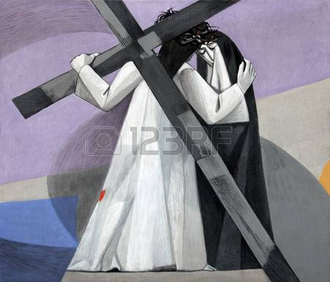
‘And his father and his mother marvelled at what was said about him; and Simeon blessed them and said to Mary his mother, “Behold, this child is set for the fall and rising of many in Israel, and for a sign that is spoken against (and a sword will pierce through your own soul also), that thoughts out of many hearts may be revealed.” ^{(Lk.2:33-35)}
As I pushed and shoved to move through the crowds to be as close to my Son as I could, we came to a place in the road where he stopped. He saw me. And we looked into each other’s eyes. I didn’t want him to see my tears or know my pain, but I long ago accepted how thoroughly he knew me. The love from my heart poured out in the only embrace I could give him, as I quietly said the prayer he taught us: “Father, may your Kingdom come and your will be done on earth as it is in heaven.” He nodded so slightly, took a deep breath and moved on up the hill. The sword passing through my heart had blessed his mission, and I knew he knew it.
Thank him with me, even now, that he has become so completely one with us, feeling the separation and loss that every person in the world knows who has lost a loved one. And, he has understood the heart of every loving mother who grieves at the suffering of her children.
Lord Jesus, help us walk in your steps….(pause)…

THE FIFTH STATION:
SIMON HELPS JESUS CARRY HIS CROSS.
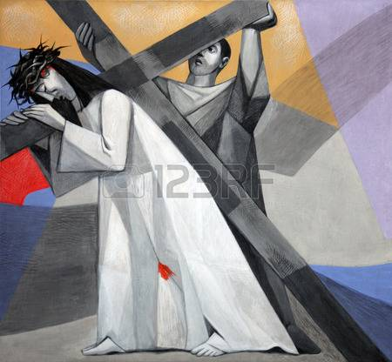
‘And as they led him away, they seized one Simon of Cyre′ne, who was coming in from the country, and laid on him the cross, to carry it behind Jesus.’ ^{(Lk.23:26)}

Now reflect with me on what it must have been like for my Son to simply not be able to carry the cross any further alone. I was so relieved that he was getting help at the time, even though my heart went out to Simon who was drawn into Jesus’ journey.
As we look back, we can give thanks that Jesus entered into our life, even in this gesture of help. Jesus came to know the experience of all of us who must depend upon others, who can’t make it alone. Even in this final journey, Jesus would not even have the satisfaction of being able to do this on his own.
Let’s pause for a moment to express to him now, whatever is in our hearts.

Lord Jesus, help us walk in your steps….(pause)…

THE SIXTH STATION:
VERONICA WIPES THE FACE OF JESUS.
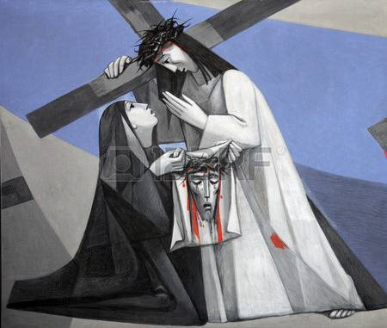
‘[H]e had no form or comeliness that we should look at him, and no beauty that we should desire him. He was despised and rejected by men; a man of sorrows, and acquainted with grief; and as one from whom men hide their faces he was despised, and we esteemed him not. ^{(Is.53:2-3)}
I can’t describe his face, with the blood and the sweat, and the bruises and swelling from the beatings. As a mother, I can hardly tell you that there was even spit on his face. It was the face of solidarity with all who have ever experienced abuse and violence. Then, out of the crowd came a woman whose compassion for my Son was so great that she pushed passed the Roman soldiers and wiped his face with her veil. Oh, how I loved her for that. The look between them touched me deeply. His clean face, for a moment, revealed the loving face of the Son I loved.
As he smiled at the woman and continued on the journey, those of us nearby looked at her veil and saw the gift he gave her. There on her veil was a stunning likeness, a true icon of the cost of his sacrifice and the depth of his solidarity with all who suffer. This image is his gift to us forever, to always contemplate his likeness, his union with us in our worst rejection and suffering.
Lord Jesus, help us walk in your steps….(pause)…
THE SEVENTH STATION:
JESUS FALLS THE SECOND TIME.
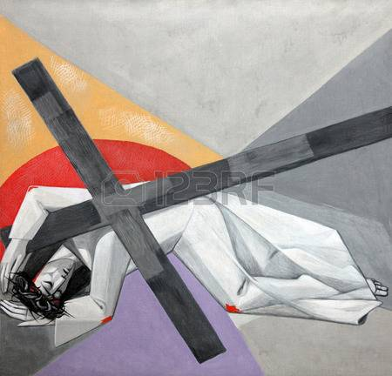
All we like sheep have gone astray; we have turned every one to his own way; and the Lord has laid on him the iniquity of us all.^{(Is.53:6)}…‘He committed no sin; no guile was found on his lips.’ ^{(1 Peter 2:22)}

When my Son fell the second time, my heart sank as he seemed to just lose control and stumble and crumble to the ground. The way he fell to his knees on the hard stones, I could feel the jarring pain through my whole body. Helpless to help him, I again wondered if he could make it.
As I look back with you today, I imagine that this fall placed him together with people with disabilities, with people suffering from all kinds of physical diseases that weaken them, and with all who are aging and must confront the limits of their bodies. My prayer is that all God’s people who know the suffering of these disabilities might know that they can always turn to my Son for understanding and comfort.
With gratitude in our hearts, we take a few moments to find the words to express our feelings to him.
Lord Jesus, help us walk in your steps….(pause)…
THE EIGHTH STATION:
JESUS MEETS THE WOMEN OF JERUSALEM.
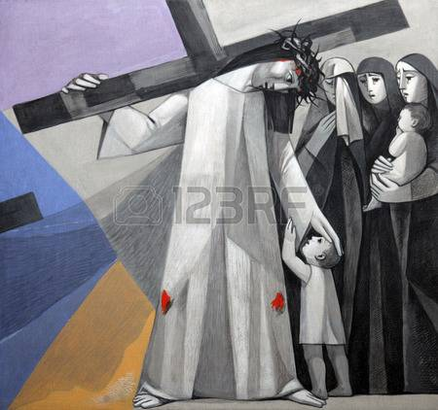
And there followed him a great multitude of the people, and of women who bewailed and lamented him. ^{(Lk.23:27)}
This moving scene filled my mother’s heart with even more love for him. As I had seen him comfort so many groups of people during his life, now he comforts this group of women and children in Jerusalem. They aren’t here to condemn him. What a remarkable meeting. They try to comfort him, as he looks on them with love and compassion. During his ministry he had come to grieve for Jerusalem. Now, my son gives them a special mission. Soon they would understand that this suffering they witnessed so closely was for them. Soon they would witness the suffering of Jerusalem and have their chance to bring their compassion and faith to their children and the people of their city.
It is good to reflect here, with him, on the mission each of us has that can be shaped by this encounter with his suffering, death and resurrection “for me.” Thank him for this brief time to recall the gift we have received.

Lord Jesus, help us walk in your steps….(pause)…
THE NINTH STATION:
JESUS FALLS THE THIRD TIME.
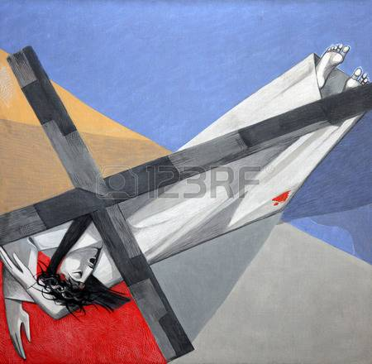
“But I am a worm, and no man;
scorned by men, and despised by the people. All who see me mock at me, they make mouths at me, they wag their heads; “He committed his cause to the Lord; let him deliver him, let him rescue him, for he delights in him!” ^{(Ps.22:6-8)}

I will always remember this final fall. Having endured such a beating and having lost so much blood, my son simply collapses. I saw him lay there on the ground and I thought he was dead. His arms spread out and his face in the dirt, Jesus found himself in solidarity with all who fall in any way.
Contemplating how the soldiers roughly pulled Jesus up and made him take the last steps to Calvary, take a few moments to speak with him, expressing your gratitude for his understanding for every weakness or failure you have ever experienced.

Lord Jesus, help us walk in your steps….(pause)…

THE TENTH STATION: JESUS IS STRIPPED.
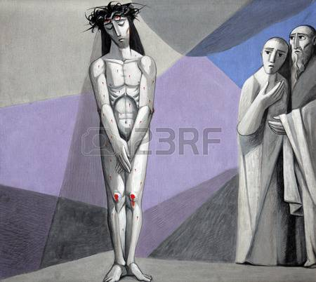
Christ Jesus…‘who, though he was in the form of God, did not count equality with God a thing to be grasped, but emptied himself taking the form of a servant, being born in the likeness of men. And being found in human form he humbled himself and became obedient unto death, even death on a cross.’^{(Philippians 2:6-8).}

The sword passed through my heart again to watch my son so violated this way. They intended to shame him even more by executing him naked. They simply had to strip him of any dignity a human being could have left. I remember looking at this body I had bathed and cared for, now with all his wounds re-opened and bleeding, so exposed for everyone to see. Now I see all the people in the world who are vulnerable and without any defense, all those whose dignity is violated, and I see this act of stripping as placing my son so completely with those who suffer. His incarnation was about to be complete.
Please pause to express what is in your heart and to give him thanks that this is all so that you might be free from the power of sin and death.
Lord Jesus, help us walk in your steps….(pause)…
THE ELEVENTH STATION:
JESUS IS NAILED TO THE CROSS.
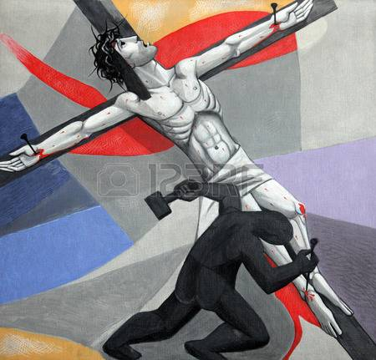
So they took Jesus, and he went out, bearing his own cross, to the place called the place of a skull, which is called in Hebrew Gol′gotha. There they crucified him, and with him two others, one on either side, and Jesus between them. ^{(Jn.19:17-18)}

Today, as I remember him lying on the cross, with his arms outstretched, it is the sound of the hammer hitting the nails that stays with me. I remember pulling the first of many wood splinters from his fingers as a child working in Joseph’s shop. Against his precious hands and wrists, that touched and healed so many, a nail was placed, and a hammer pounded the nail through his flesh and into the wood of the cross. The sound – metal against metal – that ring – and the look on his face – the spasm of his whole body – I will never forget. Then, the other hand and finally his feet are nailed to the cross.
Spend some time with him now, imagining how they lifted him up on the cross, nailed there, that you might be free.

Lord Jesus, help us walk in your steps….(pause)…
THE TWELFTH STATION:
JESUS DIES ON THE CROSS.
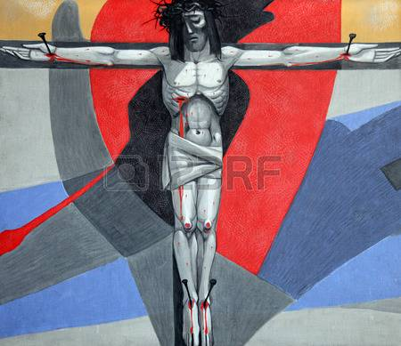
After this Jesus, knowing that all was now finished, said (to fulfil the scripture), “I thirst.” A bowl full of vinegar stood there; so they put a sponge full of the vinegar on hyssop and held it to his mouth. When Jesus had received the vinegar, he said, “It is finished”; and he bowed his head and gave up his spirit. ^{(Jn.19:28-30)}

The sword of helplessness split my heart in two as I watched him struggle to breathe, pulling himself up to let air out of his lungs. With incredible courage and compassion, he spoke of mercy and love. There on that cross he gave me to John, and gave me to the Spirit filled Church that would be born on Pentecost. Then, after he gave himself into God’s hands one last time, he took his last breath and he died. It is unforgettable to watch life leave the body of someone you love.
At the foot of his cross today, listen to my son tell you of his love for you. Speak to him from your heart.

Lord Jesus, help us walk in your steps….(pause)…

THE THIRTEENTH STATION:
JESUS IS TAKEN DOWN FROM THE CROSS.
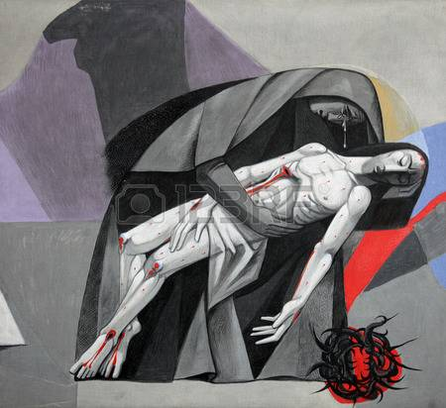
The body of Jesus was removed from the cross.
Near the cross of Jesus stood his mother and his mother’s sister, Mary, the wife of Clopas, and Mary Magdalene…’ ^{(Jn.19:49)} And many women were there, watching from a distance, the same women who had followed Jesus from Galilee and looked after him.’ ^{(Mt.27:55)}
We waited what seemed like a long time before we had permission to take his lifeless body off that cross. And, it took so long to remove the nails, and to finally lower his body to the ground. They removed that horrible crown of thorns from his head and wiped his face clean before letting me hold his body one last time. He had been given to me for only a brief time. When he left home three years before, I was so proud of him and excited to experience what God would do through him. There at the foot of the cross, my heart torn by grief, but always trusting in God’s promise, I asked only to be God’s servant for what was ahead.
Let yourself join me in receiving this mystery of the death of Jesus being so real and complete. Join me in speaking with him, heart to heart, about our gratitude for how he has transformed the power of death.
Lord Jesus, help us walk in your steps….(pause)…
THE FOURTEENTH STATION:
JESUS IS LAID IN THE TOMB.
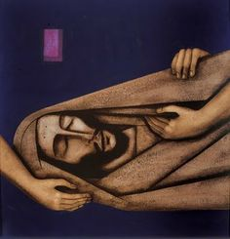
When it was evening, there came a rich man from Arimathe′a, named Joseph, who also was a disciple of Jesus. He went to Pilate and asked for the body of Jesus. Then Pilate ordered it to be given to him. And Joseph took the body, and wrapped it in a clean linen shroud, and laid it in his own new tomb, which he had hewn in the rock; and he rolled a great stone to the door of the tomb, and departed. ^{(Mt.27:57-60)}
No mother should ever have to bury a child. Just a short time before this day, Jesus looked into Lazarus’ tomb. He must have known he would be laid in a tomb like that soon. And when he thanked God for hearing his prayer, he must have known that the Father who sent him would give him life that would never die. In just a few days, this tomb would be empty and forever a sign of Jesus’ surrender to the forces of sin and death, for us.
As we picture this scene, let us place the image of the empty tomb before our eyes and know that, through the eyes of faith, all tombs are empty. Today, join me in giving him thanks. Join me in signing ourselves with the sign of his cross, in the name of the Father and of the Son and of the Holy Spirit. Amen.
Lord Jesus, help us walk in your steps….(pause)…

CLOSING PRAYERS:

Our Father…Hail Mary…Glory be…

Lord Jesus Christ,
your passion and death
is the sacrifice that unites earth and heaven
and reconciles all people to you.
May we who have faithfully reflected on these mysteries follow in your steps
and so come to share your glory in heaven
where you live and reign
with the Father and the Holy Spirit
one God, for ever and ever.
Amen.
